The Closest Galaxy Canis Major dwarf

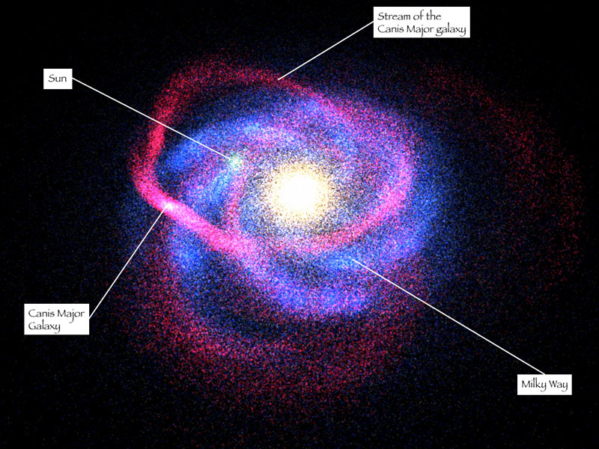

Mohammadreza Badpa – 29th March 2021 – Astronomy

Illustration Credit & Copyright: R. Ibata (Strasbourg Observatory, ULP) et al., 2MASS, NASA

The Canis Major Dwarf Galaxy is only 25,000 light years from the Sun, and 42,000 light years from the Galactic center. It too, is well-hidden by the dust in the plane of the Milky Way - which is why it wasn't discovered until recently.

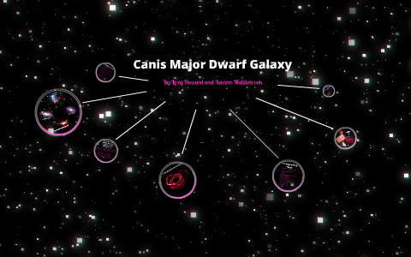sThis galaxy is also being pulled apart by the Milky Way's gravity - as it orbits the Milky Way, it is leaving a long filament of stars, gas, and dust in its wake. This 200,000-light year-long filament is known as the Monoceros Ring, and actually wraps three times around our galaxy! The Canis Major Dwarf galaxy was discovered in the course of the investigation of this Ring, which was first discovered in 2002.

The closest known galaxy to us is the Canis Major Dwarf Galaxy, at 236,000,000,000,000,000 km (25,000 light years) from the Sun. The Sagittarius Dwarf Elliptical Galaxy is the next closest, at 662,000,000,000,000,000 km (70,000 light years) from the Sun.

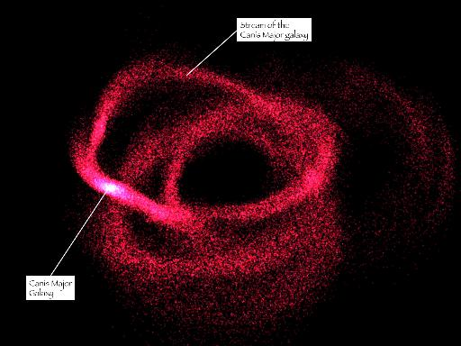The Large Magellanic Cloud, 1,690,000,000,000,000,000 km (179,000 light years) away, was once

considered the nearest galaxy outside of the Milky Way. The Small Magellanic Cloud is 1,980,000,000,000,000,000 km (210,000 light years) away.

To get to the closest galaxy to ours, the Canis Major Dwarf, at Voyager's speed, it would take approximately 749,000,000 years to travel the distance of 25,000 light years! If we could travel at the speed of light, it would still take 25,000 years!

The supposed small galaxy contains a relatively high percentage of red giants and is thought to contain an estimated one billion stars in all.